**A Project to Develop the Economy of Ganthier, Haiti, Through the Introduction and Growth of Clean-Fuel Farming**

Submitted by Haitian Relief Services, a non-profit organization located in River Falls, Wisconsin.

**Contact Persons:**

Dr. Curt Larson 737 South Fork Drive River Falls, WI 54022 [curtiss.o.larson@uwrf.edu](mailto:curtiss.o.larson@uwrf.edu) 715-425-5130

Capt. Pat O’Malley W8205 Highway 29 River Falls, WI 54022 [pomalley@wildblue.net](mailto:pomalley@wildblue.net) 715-425-9882

**Brief Introduction to Haiti**

Haiti, the most impoverished country in the western hemisphere, has a history of challenging environmental, social and economical changes. Because of its scarce resources and limited development, Haiti presents many areas needing improvement in the lives of its people. The disastrous earthquake in 2010 only exacerbated the conditions beyond human comprehension.

An unfortunate history of political corruption and turmoil brought Haiti to where it was at the time of the earthquake. In the past, most of the international aid given to Haiti was spent propping up corrupt regimes, particularly during the Duvalier era, with very little actually going to help the Haitian people. As a result, the international community was hesitant to help until the disastrous earthquake struck. Now the situation has changed. Haiti is on everyone’s radar and the corrupt proceedings of the past will not be tolerated.

**Environmental and Economic Situation in Haiti**

Lush, virgin forest covered 60 percent of Haiti’s land and mountainous regions in 1925. Since that time, Haiti has been deforested to the point where only 2 percent of the forest remains. In the later years, logging has occurred primarily to support the production of charcoal, a commonly used source of cooking fuel. The deforestation has created serious erosion, flooding, and land degradation problems. Soil run-off has destroyed farmland soils and polluted near-shore ocean fisheries. Reforestation efforts have been unsuccessful due to the fact that charcoal continues to be a main source of cooking fuel.

Haiti is the least developed country in the Americas and the only country in the Americas to be listed in the United Nations List of Least Developed Countries. About two-thirds of all Haitians work at small-scale subsistence farming, with coffee and mangoes as two of Haiti’s most important exports. However, this activity makes up only 30 percent of the GDP and Haiti has experienced little formal job creation over the past decade.

**Haiti Facts**

Area: 27,750 square miles; slightly smaller than Maryland, about 1/6th size of Wisconsin, and 1/8th the size of Minnesota.

Population: 10.0 million (2009 estimate), of which about 95% are of predominantly African descent.

Capital: Port-au-Prince

Languages: French; French Creole

(2)

Religions: 70% Catholic; 26% Protestant; 4% Other

Unemployment rate: 66%; estimated that 80% live in abject poverty

Literacy rate: about 53%

Life expectancy: Men 47 yrs; Women 51 yrs; 9.5% of children die before age 5

Leading cause of death: Bad water

**The Culture**

Haiti, a name that means "mountainous country," is derived from the language of the Taino Indians who inhabited the island before European colonization. After independence in 1804, the name was adopted by the military generals, many of them former slaves, who expelled the French and took possession of the colony then known as Saint Domingue. In 2000, 95 percent of the population was of African descent, and the remaining 5 percent mulatto and white. Some wealthy citizens think of themselves as French, but most residents identify themselves as Haitian and there is a strong sense of nationalism.

**Ganthier, Haiti**

Since we have been working in the Ganthier area and know the mayor and many of its residents very well, we propose to begin the project there. The farming model could then be replicated in other Haitian communities as will be discussed later in this proposal. Ganthier is a village (area) located approximately 25 miles southeast of Port-au-Prince, just south of Lake Azuei (see the map below). The community is spread out over 190 square miles and had, before the earthquake, an estimated population of 71,000 residents. People in Ganthier face a challenge every day to obtain food and water. Often, water must be carried in buckets or trucked in from distant springs. Because of the demands placed on survival, many children do not have the opportunity to seek an education. Less than 12% of the children attend school grades K-12. Average cost for school is about $300 annually per child. 9.5 per cent of the children in Haiti will die before the age of 5. Of the population, 70% lives below poverty level. Thirty per cent of the Haitian population is either ill and or malnourished. The long term impact of this project will be to change these numbers for the better. One goal of this project is to provide resource people and volunteers with a place to stay while in Haiti working on the project. They will then provide education and oversight of the project that will ultimately make it sustainable. The guest house will serve this purpose.

(3)

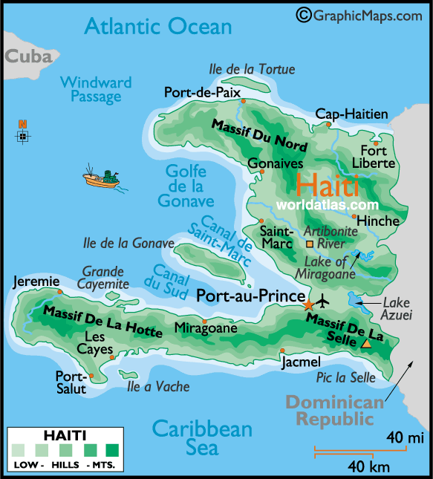

**The Guest House**

There is no hotel or hostel in the Ganthier region, so it will be necessary to build and staff a guest house. The cost of a suitable guest house has been estimated by a Haitian engineer to be $78,550. The cost of connecting the guest house to the village electrical network is estimated to be $8,595. The cost of a full-time person to provide cleaning and cooking services is $1500 per year. This salary is listed as an expense in Appendix A, but this expense should eventually take care of itself in guest fees.

**The Project Director**

For a project of this magnitude, a project director will be needed. This individual will be a local Haitian and will have to be a hardworking, educated, farmer/engineer type person with some training in business. The director, having a local presence, will be responsible for keeping the project of quality and on schedule, and will provide the day to day supervision and decision making expertise. This salary must be competitive. The consultant to the director will be an individual experienced in clean-oil farming.

(4)

**The Protos Plant-Oil Cookstove**

Roughly three billion people worldwide are forced to rely on wood, biomass, animal dung, kerosene or some other harmful fuel source for cooking. The consumption of raw materials from forests around the world amounts to three million tons per day to serve this need. The indoor air pollution that results from cooking with open fires or inefficient, dirty stoves kills 1.9 million people each year and over half of them are children.

In Haiti, the use of charcoal for a Haitian family is costing between $20-30 per month. Nearly two million poor families are paying in excess of half a billion dollars annually for inefficient cooking fuels that are not only harmful to their health but continue to burden the remaining 2% of endangered forestland.

These critical issues can be addressed head-on through proper development of localized clean-fuel crops and the utilization of the Protos plant-oil cookstove which has been integrated into the GROWIN program. Protos was developed by Bosch and Siemens Home Appliances (BSH) as a clean, safe, efficient substitute for hazardous open fires. It uses the same plant oil being grown by the farmers themselves, helping to establish local markets while concurrently improving health, saving lives and reducing the overall carbon footprint. Protos has the reliability and durability to serve as the primary cooking equipment for an entire family. Each farm family will receive a Protos cookstove and enough recycled cooking oil to run it until their first castor crop can provide the needed fuel. These are line items in Appendix A.

**Proposed GROWIN Farming Project**

The development of clean-fuel farming is the major thrust of this proposal. The goal of this project is, beginning with the Haitian village of Ganthier, to develop a farming model that can provide Ganthier and other areas of Haiti with a self sustaining income and a much needed economy. The farmers will be organized in the cooperative model, similar to those in the U.S.

This project introduces GROWIN, a farming concept researched and developed at Green Acres Plantation in Costa Rica, that can provide much needed employment for a very impoverished country. The project involves introducing the 3-tree GROWIN strategy, namely the planting of three different oil producing species. The species are castor (ricinus communis), jatropha curcas, and macauba (acrocomia aculeata). These plants produce seeds that when crushed produce oil that can be used without any further processing other than cleaning. The oil can be used to fuel lamps, cooking stoves, and unsophisticated diesel engines without further treatment. When processed into clean-fuel (biodiesel) it can also be used to fuel vehicles such as cars and trucks. This further processing is needed to remove naturally occurring waxing agents in the oil.

(5)

The waxing agents, when removed, provide useful byproducts in themselves. In fact, all byproducts of this program are useful.

Another goal of this project is to support the children of the village in getting an education. The cost to educate one child in Ganthier is about $300 a year. This project will provide much needed employment for the local people and put more parents into a position to be able to educate their children. As the project matures, funds will be used to support the construction, staffing and equipping of additional schools. A parallel goal is to restore the land that has been devastated by deforestation. As discussed later, the plan is to develop a project that can be replicated across the entire country, helping all of the people of Haiti. This goal can be obtained in the long term, since the people of the village of Ganthier will have the experience and expertise in planting, harvesting and processing of the GROWIN plants to pass along to other Haitian villages.

**Castor, Jatropha Curcas and Macauba**

The jatropha plant, native to Central America, South America, and Africa has been in existence for 70 million years. It can be cultivated at all elevations in Haiti. It grows very well in rain-fed, drought-prone areas (much of Haiti), where seed yield and oil content are both sufficient without using irrigation. It is fast growing and has a life of 50 years. The plant and seeds are toxic to animals and birds and are therefore not bothered by either, so pesticides are not needed. Jatropha oil is obtained by pressing the seeds produced in the fruit of the plant and, when processed into clean-fuel (biodiesel), is a real and cost effective substitute for hydraulic fluid and diesel oil. All byproducts of the production process are also useful. They are used in medicines,cosmetic products, tooth powder, oil based soap, eco-friendly pesticides and as soil building bio-mass. The tree itself is used as a natural fence for orchards and farms.

Jatropha will grow in a tropical climate in any soil, including severely degraded soil. It can be propagated by seeds or cuttings. Use as a fence requires 300 plants per hectare. Inter- cropping in the 3-tree strategy will use 1110 plants per hectare. We will plant 1110 cuttings per hectare.To determine the best variety for an area, the GROWIN plan plants 10 varieties and, after one year, determines which variety can be used to provide the best cuttings. Jatropha curcas production maximizes at 505 gal/ha in 5 years and continues for 50 years.

Two other oil bearing trees will be intercropped with jatropha to improve the economic viability. Castor matures in 7 months and produces 250 gallons per hectare, therefore providing oil and income in the first year. To keep production at this value, it must be replanted the second year. The Macauba Palm is slower to mature, with production beginning in the fifth year and maximizing at 1200 gallons of oil per hectare after 8 years. It is inter-planted at 420 trees per hectare. It produces for 80 years, so is really the “giant” in the GROWIN 3-tree strategy.

(6)

Several reasons why the GROWIN program would be beneficial to Haiti are listed below

* Haiti has a desperate need for employment and this clean-fuel program is labor intensive, especially well suited for a country where jobs are scarce and salaries are low.
* These three trees, through greening, will add nutrients to the soil, check erosion, and stop land degradation.
* Clean-fuel provides an alternative to charcoal as a cooking fuel, and charcoal production is the main contributor to the deforestation and degradation of Haiti’s soil.
* The clean-fuel oil produced is environmentally friendly and in great demand.
* If developed sufficiently it will reduce, and could completely eliminate, dependence on crude oil imports, providing energy security, especially in rural areas.

All three trees are resistant to drought and high winds and can be planted on wasteland. They will grow almost anywhere, even on gravel, sandy, saline and low nutrient soils. They thrive even on minimal rainfall. The life expectancies of jatropha and macauba are 50 years and 80 years respectively, so replanting is not needed. The use of pesticides and other polluting substances is not necessary due to the pesticide and fungicidal properties of the plants.

The jatropha plant has many additional purposeful uses as listed below:

* Its leaves can be eaten once steamed or stewed. When crushed it can be applied near horses’ or donkey’s eyes to repel flies.
* The nuts are sometimes roasted and eaten. They can also be burned like candle nuts when strung on grass.
* Ashes from burning the roots are used as a salt substitute.
* The bark can be used as a blue dye.
* The latex strongly inhibits the watermelon mosaic virus. It has healing power for humans and is used in medicines. It can be used to make yellow dye.

For this project the initial use of the seeds will be for lamp oil, stove fuel, and for byproducts. As production increases beyond this need, biodiesel will be produced. Another huge benefit will be the reforestation of the land that was once a lush rainforest with plentiful rain, but now has been cleared of most of its trees. Today the land is baron and rainfall has been reduced in the Ganthier area. When it does rain, erosion of the land occurs. The farming of clean-oil plants and use of Protos cookstoves will eliminate the need for charcoal, saving lives through cleaner air in the home adding trees to the landscape to prevent erosion.

(7)

**Implementing the GROWIN Farming Plan**

The farming plan will be developed in 50 hectare modules. These modules will be developed as funding is available. The total land needed for the first module of this project, to be provided by Ganthier, is 55 hectares. Five hectares will be needed for the nursery, guest house, storage shed and production facility. Fifty hectares will be needed for 10 farms of 5 hectares each. Each farm will be assigned to a farm family. All major farm and processing equipment will be used on a cooperative basis. There are two approaches that can be taken here. The land in the Ganthier area is covered with heavy scrub brush that will be very difficult to remove in a reasonable time frame without at least one significant tractor. Additional heavy equipment, such as a tracked dozer and/or trackhoe, if available, would speed the process of clearing land. This equipment could be very well utilized, especially as the initial Ganthier project expands or is replicated in other areas of Haiti. Such heavy equipment would also be very useful in any attempt to harvest water requiring the construction of earthen dams. Unfortunately, it adds considerably to the initial cost of the project. The plan discussed in this proposal therefore assumes the purchase of a tractor, digger, and wagon. Heavier equipment, if available, would clear land in the Ganthier area and then move to other sites. There will still be plenty of work to be done by the farmers, as clean-fuel farming is labor intensive from beginning land preparation to final product. First year capital investment will be needed for as many as 10 modest farm homes, one tractor, one digger, one wagon, and a storage shed for machinery. The cost of these items is given in Appendix A.

**The Nursery**

The nursery will be ideally located in an area as near the school as possible. This facility will provide the macauba seedlings and will be used as an educational facility. The jatropha will initially be supplied by cuttings. Ten varieties will be planted initially and given a year to grow. After one year it will be determined which variety is best suited to the Ganthier conditions. Thisvariety will then be propagated by cuttings. Some of the work in growing the seedlings can be done by the children of the school with adult supervision as a learning exercise. This will provide a practical learning experience for the children to learn about agriculture, biology, plant genetics and economics. We have established a relationship with a clean-fuel farm in Costa Rica and initially, all genetic materials will be provided by them. We have proven that jatropha will grow in the Ganthier area, since seeds we purchased from India and planted in Ganthier produced excellent quality jatropha plants and seeds in one year. Once jatropha plants have grown in Ganthier, we can produce our own cuttings. The nursery and nursery supervisor costs are listed in Appendix A.

(8)

**The Production Facility**

The production facility will consist of one large complex and will be run as a cooperative, meaning that it will be owned by the area farmers raising the seeds being processed. A processing building will be needed to house all equipment needed to extract and process the products. Needed equipment will include a seed sheller, a seed crusher/oil extruder, a de-waxing capability, and product storage equipment. A low-tech, low cost version of the seed sheller and separator can possibly be used at each farm site to minimize transportation costs. The main production facility will best be conveniently located just outside the central village of Ganthier. The first phase of this facility is needed at the end of the first year when castor has matured. The second phase will be needed in the third year and the third phase in the sixth year. These phases are added as production increases and more refining capacity is needed. The estimated cost of the capital equipment, the production manager, and maintenance for this facility is listed in Appendix A. Details of the processing equipment phases are shown in Appendix B. The production numbers given in Appendix A assumes the macauba output begins in year five and is maximum at year eight. Once the macauba is mature and at full production the jatropha production will drop off due to shading by the larger macauba trees.

**Phase 1**

The introductory phase will involve very hard work. It will also involve research and development led by the project director. It will require a team effort of all involved to accomplish the initial phase of the project.

* The first step will be to select a project director and the ten initial farmers. These farmers will be selected by the project director and the elders of the village, with guidance by Haitian Relief Services. The farmers will sign a contract and will be allowed to work with this project as long as their performance is satisfactory as determined by the project director.
* The land will be surveyed to plot out the location of the farms and buildings. Well drilling and water harvesting will begin immediately to secure a water source for the nursery. If this fails, sufficient funds are allocated to haul and store water.
* The nursery will be built immediately and the first macauba seeds will be planted. The seedlings require most of the care and water. Once they are mature plants, care is less critical. The children of the school will be able to play a major role in the tasks of the

nursery, such as plant watering, which will supply the farmers with seedlings when they are mature enough to transplant.

(9)

* The farmers will work in teams to prepare the land for planting. The land is mostly covered in scrub brush and will need to be cleared before it can be tilled. The tractor and digger will be used to tear out the large brush unless a dozer and/or trackhoe are available. Then lighter tools can be used to remove remaining roots, etc. The farmers will work together in preparing 50 hectares for planting. Once the land is cleared of brush, the farmers will first plant cuttings of the 10 jatropha test varieties, then the castor seeds and the macauba seedlings. The goal will be to accomplish this ASAP because this determines when harvest begins. The castor will mature and produce in 7 months after planting. It will take up to 1-2 years for the jatropha plants to start producing seeds for processing and one year is lost waiting for the test plot information.

As can be seen in Appendix A, this plan calls for increased funds for farmer salaries in years two and three to allow for the addition of the second and third 50 hectare modules of 10 farms each.

The first four years of this project will yield an operating loss because of the large capital investment needed to get started. This capital investment will bear great dividends, however. The farm machinery, nursery, and production facility can serve a far larger area than we are beginning with, and therefore will allow expanding the project in the Ganthier area. There is much land available in the Ganthier area and expansion will occur as rapidly as feasible. Further land clearing can begin as soon as the farmers have the first 50 ha under control. We are scheduling the nursery to run continuously so that as further land clearing occurs, seedlings will be available. The Ganthier project is initially projected to grow by 50 ha per year for three years.

**Phase 2**

This phase will involve full operating capacity on the first 50 ha of jatropha. Castor will only be planted for the first two years on each of the 50 hectare plots and the macauba requires eight years to reach maximum production. Farmers will have some fields at full yield and others coming along. Harvesting will take place throughout the year as fruits ripen to keep the production process flowing continually. There will be required maintenance on the machinery that will need to be done to maintain the processing equipment. A flow diagram of the process is shown below:

(10)

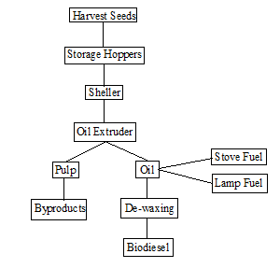

The older school children will be able to help the farmers with harvesting, becoming educated in the process. There is no intent to abuse or take advantage of the children here, but rather to help them become the next generation of clean-fuel farmers with a chance to make a decent living.

Jatropha production maximizes in 3-5 years and goes on for 50 years. If planted at 1,110 plants per hectare as in the GROWIN plan, the total output of 50 ha in full production is about 25,250 gallons of oil per year. The numbers given for oil production in Appendix A reflect the fact that 100 hectares of jatropha will be planted in year 2 and 50 additional hectares will be planted in year 3. The jatropha oil, as it comes from the seeds, can be used as fuel for lamps or cook stoves. This can eventually replace the need for charcoal, the product largely responsible for the continued deforestation of Haiti and health issues in her people. As time goes on and lamp and stove oil needs are exceeded, the main focus will be producing biodiesel, as this is a resource much needed in the world economy. The biodiesel can be used to fuel almost all diesel machinery and vehicles. The lamp and stove oil and processed biodiesel will be sold locally and to the surrounding villages. The current cost of chemically processing the oil to biodiesel is about $1.05 per gallon, with the main ingredient being methanol. This project includes a methanol reclaiming system that will reduce the chemical cost to about $.50 per gallon. It is anticipated that biodiesel would be sold at roughly $4.00 per gallon. This price would depend on market fluctuations. The current cost of petrodiesel in Haiti is about $4+ per gallon, so this could greatly affect profit. For a given field the production rate is steady after three to five years. Research on watering rate, etc., will be done and can possibly lead to increased production.

(11)

**Phase 3**

The final phase of the project at a particular site occurs when it becomes truly self-sustainable. Income at Ganthier should exceed expenses in the fifth year, providing capital to keep expanding the acreage under cultivation and providing the additional processing equipment needed. As can be seen in Appendix A, the operating expenses are kept constant as time goes on. This is perhaps unrealistic, but it can also be seen that the project, with this restriction, becomes rapidly and increasingly in the black. This will allow for needed increases in wages, etc. The people of the village will be involved in and becoming familiar with the farming of jatropha. By year three, the project provides full-time jobs for the project director, 30 farmers, one production plant manager, one nursery manager and one guest house manager. This is only the beginning and, as the project expands into the surrounding area, these numbers will grow. Starting near the end of the first year, the project will be producing its own seeds and some of its own fuel. The project will be left in control of the people of Ganthier as soon as possible. Throughout the project, and into the future as it expands, resource people and volunteers will periodically visit Ganthier to make sure things are going as planned and to ensure that the profits are being used appropriately.

**A Nice Problem to Have**

As the macauba palm matures, the potential for growth of projected income at the farmer level creates a very nice problem to have. Farmers in the project will be experiencing returns which are increasingly out of concert with the norm in Haitian farmer income. At this point the farmer cooperatives will have funds available to make significant contributions to their community. These contributions will be in the form of financing improvements in local infrastructure such as construction of schools, community centers, housing, waste treatment and/or microloans allowing other farmers to get started in similar clean-fuel farming. At this point the project is not only sustainable, but is expandable to any available degraded land. Over the long term it can be expanded to give the Haitian people something they have never had, an economy. The available funds are displayed in Appendix A. Since Haitian Relief Services will take nothing from the project, once excess funds are poured back into the Ganthier community, the bottom line will show zeroes.

**Replicating the Project throughout Haiti**

The rough clearing of the land can proceed much faster than the labor intensive preparation of the land for farming that follows, especially if heavy equipment is available. As soon as the time gap allows and if funding is available, replication of the Ganthier project could begin in a second nearby area of Haiti. This new startup will entail another startup cost but could share the same project director and, if near enough to Ganthier, could use the same guest house, nursery and processing facility. We proposed to begin in Ganthier because we are familiar with people there.

(12)

Before moving on to other areas, local leaders would have to be consulted to ensure local support for the project. Other Haitian villages that could eventually be considered, not in any particular order, are Gonaives, Port de Paix, Cap-Haitien, Mirebalais, Hinche, Jacmel, Les Cayes, Montrouis, St. Marc, and Jeremie. All yearn for investment and jobs. The budget for this project is shown in Appendix A. Appendix A includes all start up costs at Ganthier, including the cost of the overall project director. The cost of a tracked dozer and a trackhoe, which would expedite the rough clearing of land are not included in the budget, but are listed at the end, should sufficient funding be available. Moving to an additional site would have similar costs, but would not necessarily include the cost of the project director. If the site is nearby, the guest house and nursery could also be shared. For the processing facility to be shared, additional equipment would have to be provided. Appendix A illustrates the rapid rate at which this project attains sustainability even if only 150 hectares are planted on each site. Beginning in year five, the project becomes self sustaining with profits growing at a rapid rate through year ten, when all 150 hectares are in full production and production stays level. When the Haitian people, desperate for jobs and an economy, see how this clean-oil farming project works, it is likely that these profits will be invested in infrastructure and in virtually endless expansion. Much of the land in Haiti is useful only for clean-oil farming and not for food crops. This project will provide an economy allowing Haitians to buy food they cannot grow.

This project can be replicated in any village in the world where soil and climate conditions make clean-oil farming feasible. It is in third world tropical countries with degraded land that these trees thrive best.

(13)

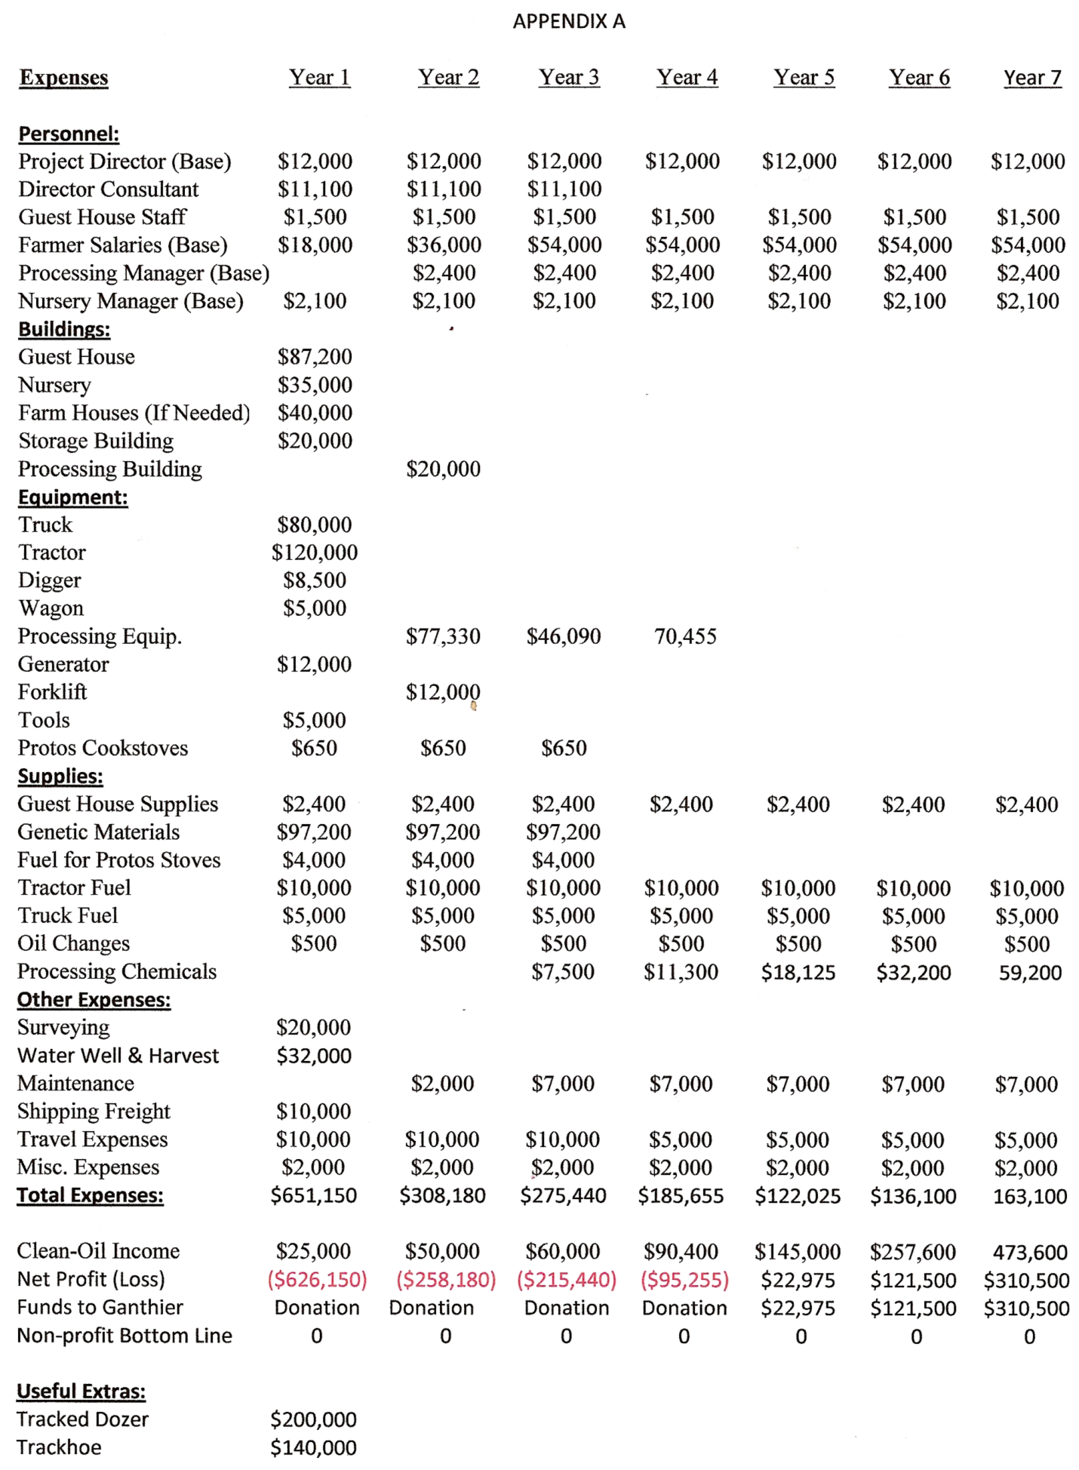

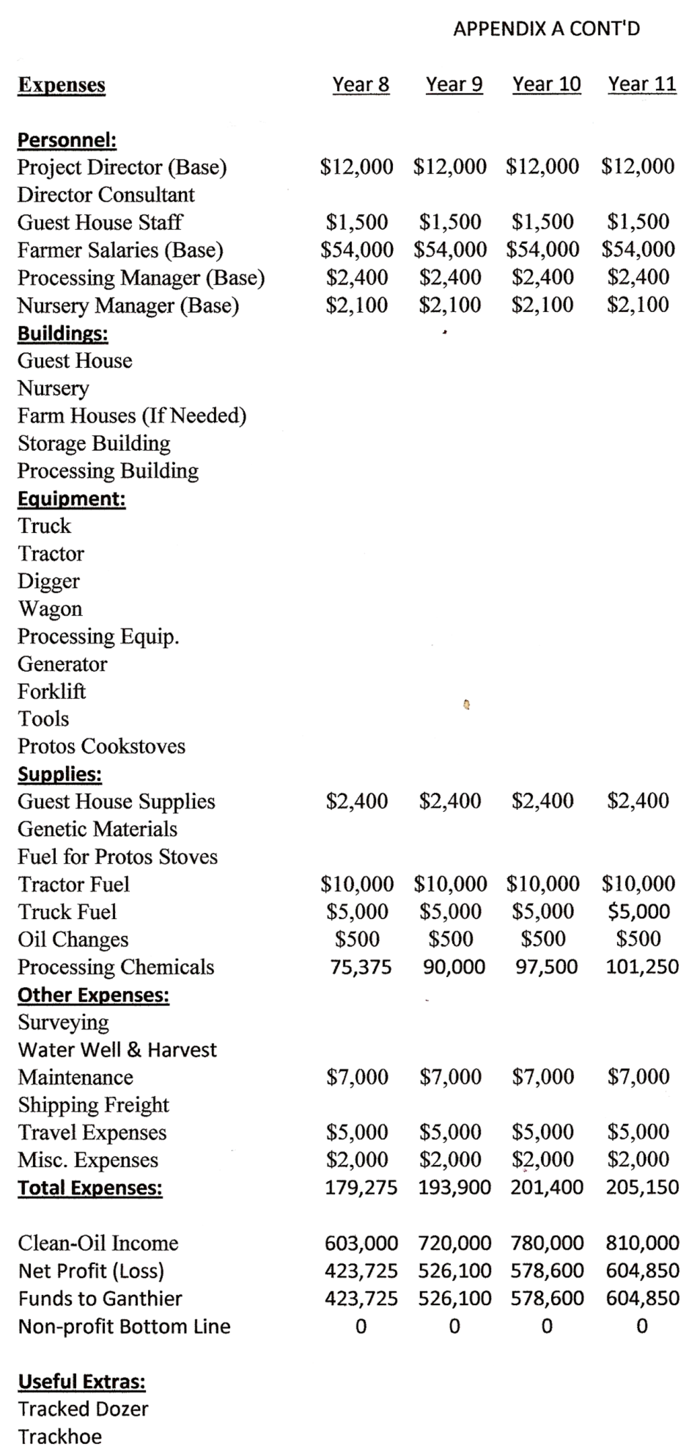

Appendix B

|  |  |  |  |
| --- | --- | --- | --- |
|  |  |  |  |
| Capital Equipment needed for Processing: |  |  |  |
|  |  |  |  |
| Phase 1 Processing - Up to 100 acres full production: | Quantity | Unit Cost | Total Cost |
|  |  |  |  |
| M70 Oil Press | 2 | $9,500 | $19,500 |
| BioPro380 + INCOSEP | 1 | $20,000 | $20,000 |
| Rajkumar Sheller | 1 | $2,000 | $2,000 |
| Commodity Cleaner | 1 | $7,600 | 7,600 |
| Methanol reclaim unit | 1 | $7,000 | 7,000 |
| Fuel pump and meter | 1 each | $600 | $600 |
| Methanol pump, hose, and nozzle | 1 each | $700 | $700 |
| 100 gallon fueling cart | 1 | $2,000 | $2,000 |
| Centrifuge | 1 | $2,900 | $2,900 |
| Bins, Augurs, tanks, controls |  |  | $8,000 |
| Subtotal |  |  | $70,300 |
| Unforseen expenses (10% of Subtotal) |  |  | 7030 |
| Total for Phase 1 Processing |  |  | $77,330 |
|  |  |  |  |
|  |  |  |  |
| Phase 2 Processing - Up to 200 acres full production: |  |  |  |
|  |  |  |  |
| M70 Oil Press | 2 | $9,500 | $19,000 |
| BioPro380 + INCOSEP | 1 | $20,000 | $20,000 |
| Centrifuge | 1 | $2,900 | $2,900 |
| Subtotal |  |  | $41,900 |
| Unforseen expenses (10% of Subtotal) |  |  | 4190 |
| Total for Phase 2 Processing |  |  | $46,090 |
|  |  |  |  |
|  |  |  |  |
| Phase 3 Processing - Up to 400 acres full production: |  |  |  |
|  |  |  |  |
| M70 Oil Press | 4 | $9,500 | $38,000 |
| T76 Drywash System | 2 | $6,325 | $12,650 |
| Commodity Cleaner | 1 | $7,600 | $7,600 |
| Centrifuge | 2 | $2,900 | $5,800 |
| Subtotal |  |  | $64,050 |
| Unforseen expenses (10% of total) |  |  | 6405 |
| Total for phase 3 Processing |  |  | $70,455 |